





Wallet Walkthrough – Hands-on Wallet Setup
Objective/Aim:
The objective of this lab is to understand how to set up and use a cryptocurrency wallet by performing a hands-on walkthrough. This includes creating a new wallet, securing the seed phrase, exploring wallet features, and understanding how transactions are made.

Apparatus/Software Used:
- Internet-connected device (Laptop)
- Browser (Chrome)
- Cryptocurrency wallet app or extension (e.g., MetaMask)
- Notepad for saving recovery phrase securely

Theory/Concept:
A cryptocurrency wallet is a digital tool used to store, send, and receive cryptocurrencies. It manages our public key (wallet address) and private key (used to authorize transactions).
There are two main types:
- Hot Wallets: Connected to the internet (e.g., MetaMask)
- Cold Wallets: Offline and more secure (e.g., Ledger)
When setting up a wallet, a 12-word seed phrase is generated. This is a backup for recovering the wallet and must be stored securely.
Wallets can be used on:
- Mainnet: Real network with actual cryptocurrency.
- Testnet: For practice using test tokens with no real value.
We can:
- View their balance and transaction history
- Send/receive crypto
- Tip: Never share your seed phrase. Always double-check addresses before sending funds.

Procedure:

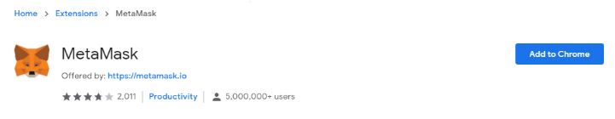
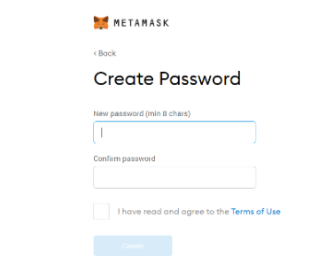
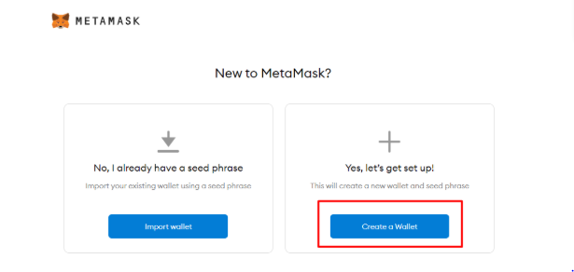
Install a wallet app or browser extension (e.g., MetaMask).
Set a strong password
generate a 12-word recovery phrase (write it down and store it safely).

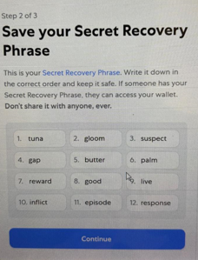
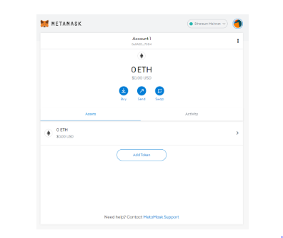

This is the recovery phase which appears only once

Observation:
• The recovery phase is the only way to connect to your wallet and it only appears only once.
• Ones you lost it you can recover it cannot any way.
• Private key should not be shared.

